RPM MX5 SOUTH COAST RUN
21st October to 27th October 2023

On Saturday 21st October 8 MX5 cars from the R.P.M chapter left HARTLEY for our 8 day venture down the south coast and up into the snowy mountains
Our first stop was at the Hampton Halfway Hotel for morning tea and then onto the Taralga Hotel for an enjoyable lunch Our next stop was at the Goulburn Historic Water Works Museum where Robyn had organised a tour and talk on the history of the Museum . After this we made our way to our Motel and then to the Goulburn Soldiers Club for dinner

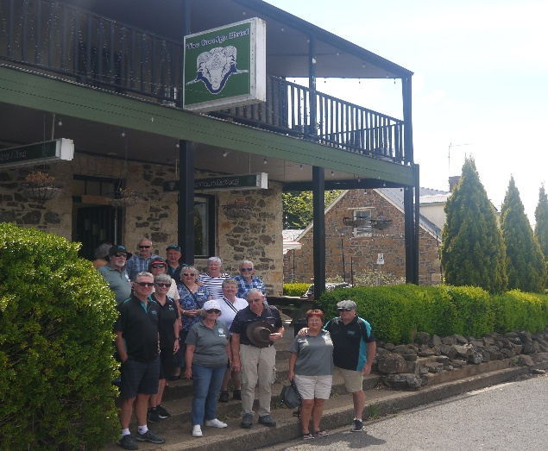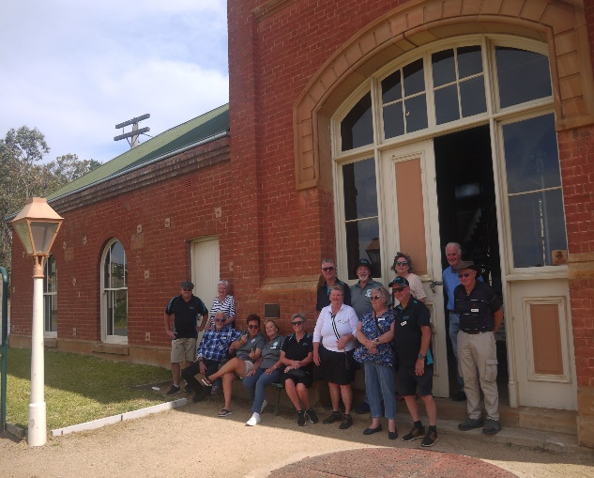
Taralga Hotel - Lunch Goulburn Historic Waterworks
Sunday morning we met at Trappers Bakery for breakfast and then to Braidwood for morning tea. The better drivers then enjoyed a run down Clyde Mountain to Batemans Bay and then onto Mogo for lunch and some people visited the Zoo. We then drove out to the coast and down to Narooma for our 2nd night . Dinner was out at the Narooma Golf Club where Robyn had booked tables for us with a view down the coast

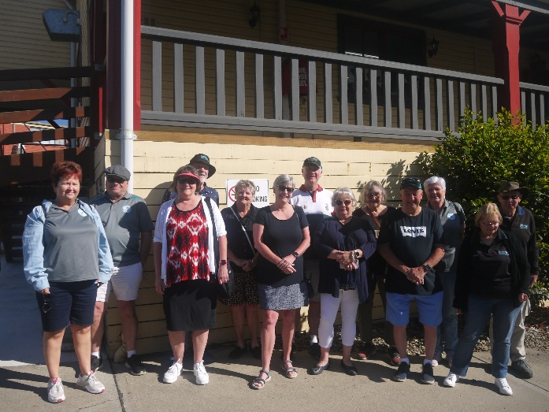
Trappers Bakery Breakfast
Monday morning was started with a 350 m walk along the Mill Bay Boardwalk where we saw a sting ray and lots of fish.
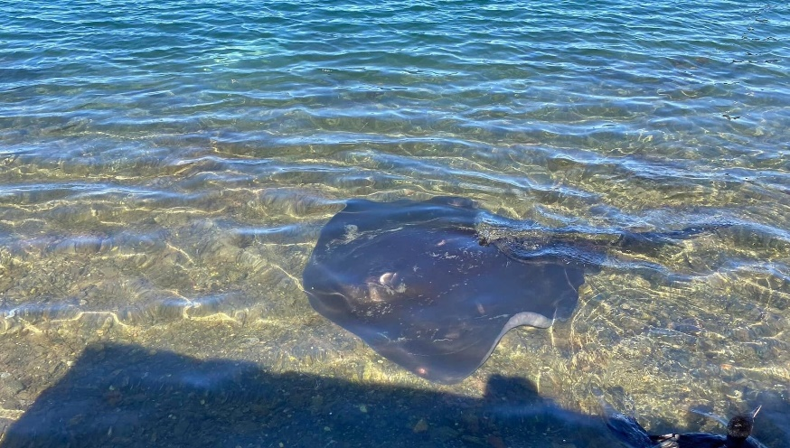Mill Bay Local ???
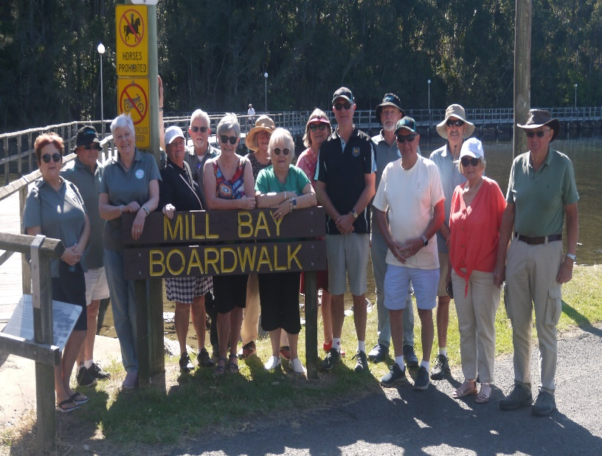
We then headed back to the highway and down to Central Tilba and morning tea at the Eumen tea house ,After morning tea Robyn had organised a talk and tour around Foxglove Garden at Tilba Tilba, then back to Central Tilba for lunch and some retail therapy, We next headed down to Cobargo and saw the terrible damage the fires had caused last year , next out to Bermagui and down to Tathra where we hoped to see the Tathra Wharf Museum but unfortunately it was closed for maintenance so a short run into Bega for our next night , We had a long down hill walk to Club Bega for dinner and were not looking forward to the climb back up the hill , we enquired if they had a courtesy bus but not this night . the man running the bar took pity on us and drove us back to the motel which was very appreciated.
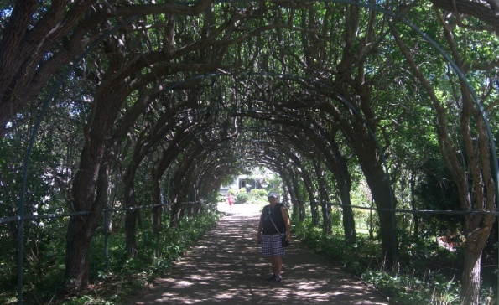Foxglove Spires
Tuesday morning we visited the Bega cheese Factory for coffee and cake then down to . Candelo and a very scenic drive up to Bemboka We next stopped at Nimmitabel Bakery for morning tea . next onto Cooma and down to Maffra to Dalgety and up to Berridale and back to Cooma for our next night. Chris and Donnell now joined us for the rest of our holiday
Wednesday next morning Robyn organised for the Cooma Car Club Museum to open for us to visit . they had some very interesting cars and an early sixties milk bar.
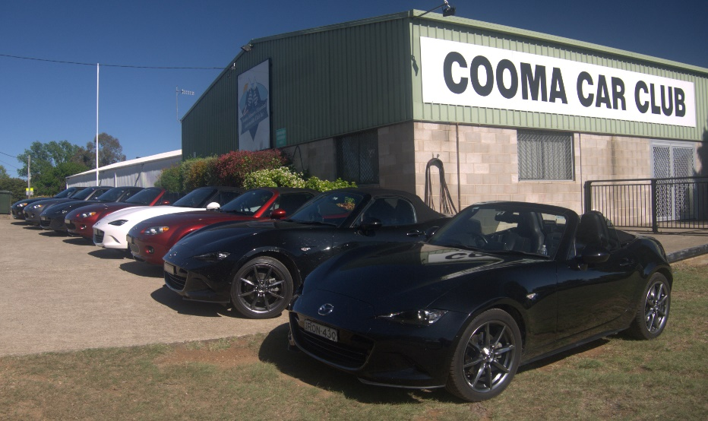
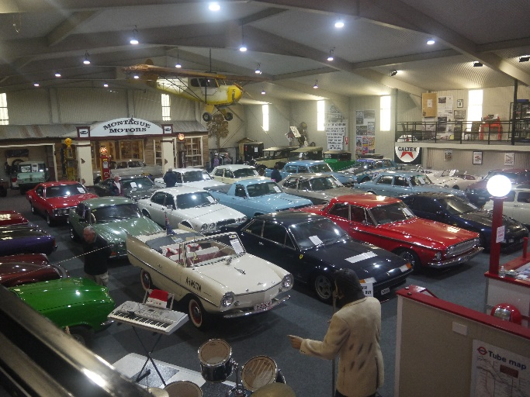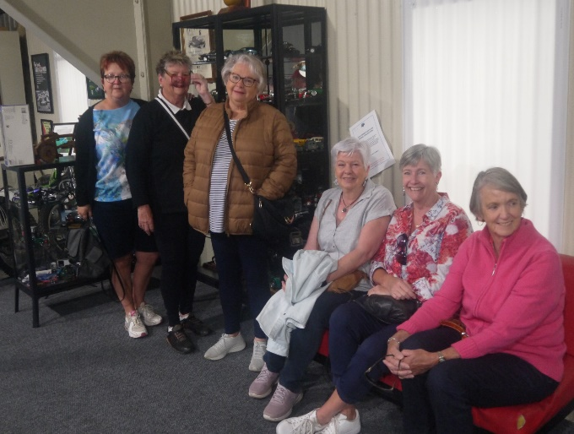
On leaving Cooma our next drive was out to Jindabyne and up to Guthega where we struck a very rough dirt road guess who was very unpopular ?, we decided to give Guthega a miss and more dirt onto Smiggin Hole but every thing was closed so onto Charlottes Pass and was it worthwhile , fantastic scenery but VERY cold so back to our accommodation at the Jindy Inn ( a great place to stay ) dinner this night was at the Clancy’s Brassiere Banjo Patterson Inn Charlotte’s Pass
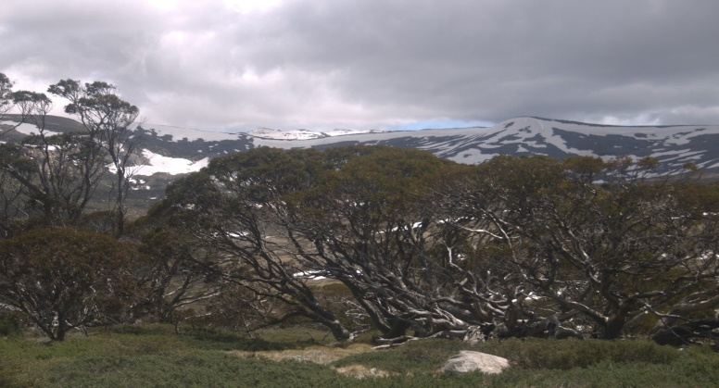
Thursday our next day was up the Alpine Way to Crackenback Lake and onto Thredbo for morning tea Unfortunately every business but the bakery was closed, we then drove down a very twisty road to Khancoban for lunch, along the way we went off road and saw some Brumby’s Kangaroos and emus, now all the BOY RACERS took off for the trip back to Jindabyne Dinner was at an Italian restaurant where we all enjoyed the night
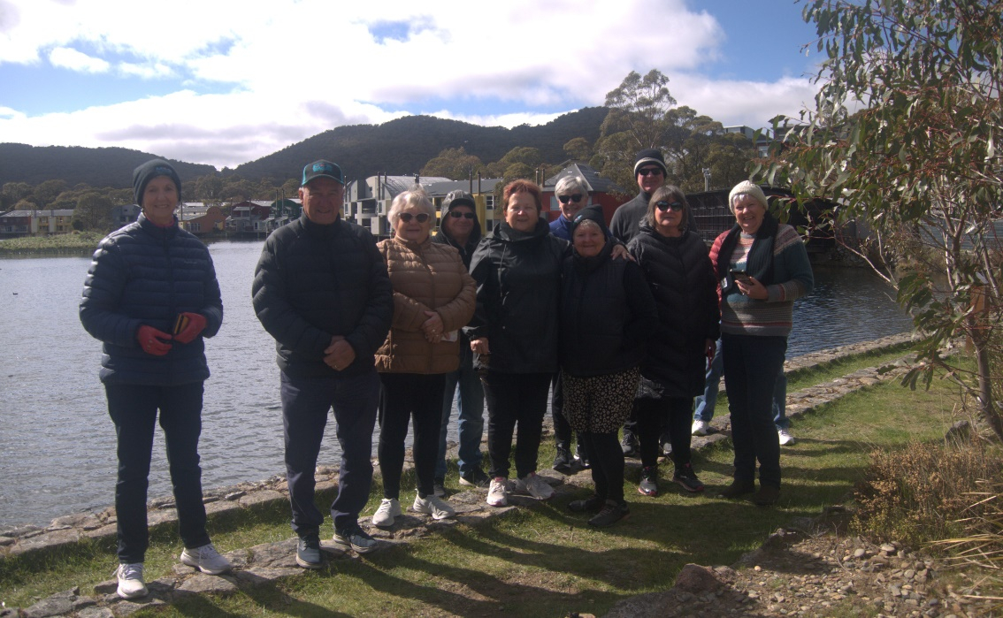
Lake Crackenback

The next day we enjoyed a very scenic run to Adaminaby where we had a film and talk about the building of the Snowy Hydro scheme Museum, we next drove down to Talbingo and had a lunch and a drive out to see the dam and the huge lake . after this we drove to Tumut and onto Gundagai for our last night
A special thanks to Robyn for all her hard work in organising our meals and morning tea stops and Ron Questor and Grant Briggs for sharing the last car duties.

